Membership Application Form

FIRST NAME: |  |  | LAST NAME:
ADDRESS: |  |  |  | POST CODE:
EMAIL ADDRESS:
Please make sure it is easy to read!
TELEPHONE NUMBER:
How did you hear about BWCRA? |  |  | I attended a BWCRA event ☐  Advertising banner ☐  Advertising poster ☐  Through social media ☐  Through a friend ☐  Through a web search ☐  Other ☐
By giving BWCRA your email address you are giving BWCRA consent to contact you regarding membership and other topics related to the community. We will not share your details with any other organisation
PAYING YOUR ANNUAL MEMBERSHIP –

Membership runs April to March and costs £12 a year.
If you join later in the membership year, you pay a reduced amount (see the table)
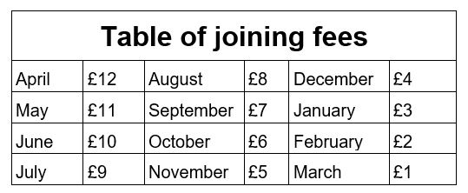
- You can pay by cash (please don’t post it!) Drop this form off with the membership fee to the BWCRA Treasurer, Tarel Lavelle at 13 Ffordd y Dociau (on the ASDA side in Phase 2).

- You can pay by cheque. Please make it payable to BWCRA and put your name and address in capitals on the back. Post it to BWCRA Treasurer, Tarel Lavelle at 13 Ffordd y Dociau, Barry, CF62 5BN

- You can pay via PayPal by visiting the ‘Membership’ page at our website www.bwcra.org. You don’t need a PayPal account to use it as you can use a debit or credit card directly via the PayPal link.

- You can make a bank-to-bank transfer. Please put your name and address in the reference line so we know who it came from! Our account details are

Lloyd’s Bank
Account name: BWCRA
Sort code: 30-90-90
Account number: 32061960

